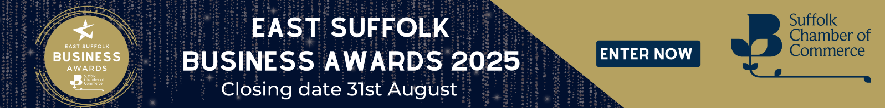

**Medium Business of the Year  
Award Criteria**

The Large Business of the Year Award (11-50 employees) will be given to the company that best demonstrates all-round excellence in business.

Open to all organisations within East Suffolk. This award will go to the company that has proved to be experts in their field of work, backed by a strong financial performance, while demonstrating a clear understanding of the markets that it operates in.

Winning the Medium Business award is recognition of outstanding achievement in business to date. Judges will look for evidence of good business vision, good leadership, innovative ideas and continuous investment.  
  
**How to enter**

1. **Check out our East Suffolk area map to ensure your business is within the entry area**
2. **Download and fill in our application form**
3. **Tell us about your business (approx.1000 words) this could include some of the following; Your history, customers, competitors, challenges, opportunities, your vision and anything else that you feel is relevant.**
4. **For your entry wording/evidence (no limit on this wording) the judges will be looking for examples of:**

* Evidence of how you have improved your business and its financial performance (we appreciate this may have been more challenging with the increases to cost of living) – tell us what you have achieved and share with us your future plans.
* How has your business gained a competitive edge? *Examples being*..   
  Diversification into new products and markets  
  Research and innovation  
  Commitment to quality  
  Innovative marketing and communications
* Demonstrate how you ensure high service standards and how you deliver exceptional customer care & benefits to drive new and repeat business.
* Provide evidence of your commitment to staff through staff training, development, wellbeing initiatives, work-life balance programme, employee benefits.
* Corporate social responsibility commitments - Provide evidence of the difference that you have made to the local economy and communities, examples being:

Environmental & sustainability initiatives  
Local community support  
Health & wellbeing of your staff

* Any accolades and testimonials.
* Anything else relevant you wish to share?

1. **Tell us why you believe your organisation deserves to win the Suffolk Chamber East Suffolk - Medium Business of the Year Award (max 500 words)**

If you are selected as one of our category finalists, our judges for this category may wish to visit your business, they will arrange this direct with yourselves at a date and time convenient to both parties.